**DAILY ONLINE ACTIVITIES SUMMARY**

|  |  |  |  |  |  |  |  |
| --- | --- | --- | --- | --- | --- | --- | --- |
| **Date:** | **02/07/2020** | | | | **Name:** | **Churashma** | |
| **Sem & Sec** | **4th SEM 'A' Section** | | | | **USN:** | **4AL18CS019** | |
| **Online Test Summary** | | | | | | | |
| **Subject** | | **No test** | | | | | |
| **Max. Marks** | | **-** | | **Score** | | **-** | |
| **Certification Course Summary** | | | | | | | |
| **Course** | **Blockchain basics** | | | | | | |
| **Certificate Provider** | | | **greatlearning academy** | **Duration** | | | **2.5 hours** |
| **Coding Challenges** | | | | | | | |
| **Problem statement 1: Write a Java Program minimize the maximum difference between adjacent elements in an array.** | | | | | | | |
| **Status: completed** | | | | | | | |
| **Uploaded the report in Github** | | | | **yes** | | | |
| **If yes Repository name** | | | | **https://github.com/Churashma/Lockdown-coding** | | | |
| **Uploaded the report in slack** | | | | **yes** | | | |

ONLINE TEST DETAILS: No test

CERTIFICATION COURSE DETAILS: Today I studied about role of intermediaries. Blockchain Won't Cut Out Intermediaries After All. One of the primary advantages of blockchain, the thinking goes, is that it creates trustless relationships in cryptocurrency ecosystems. Before cryptocurrencies, digital transactions between two parties required a trusted third party to act as an intermediary.

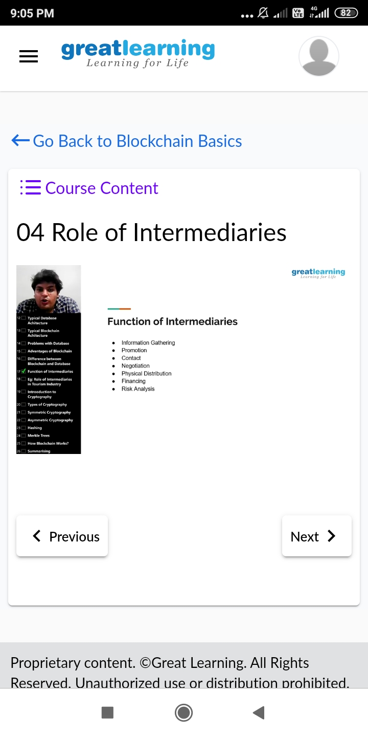

**CODING CHALLENGES DETAILS**:

Problem statement 1: Write a Java Program minimize the maximum difference between adjacent elements in an array.

